Workflow : https://akmzoho.app.n8n.cloud/workflow/jKOCMXFHnfA3MjXr
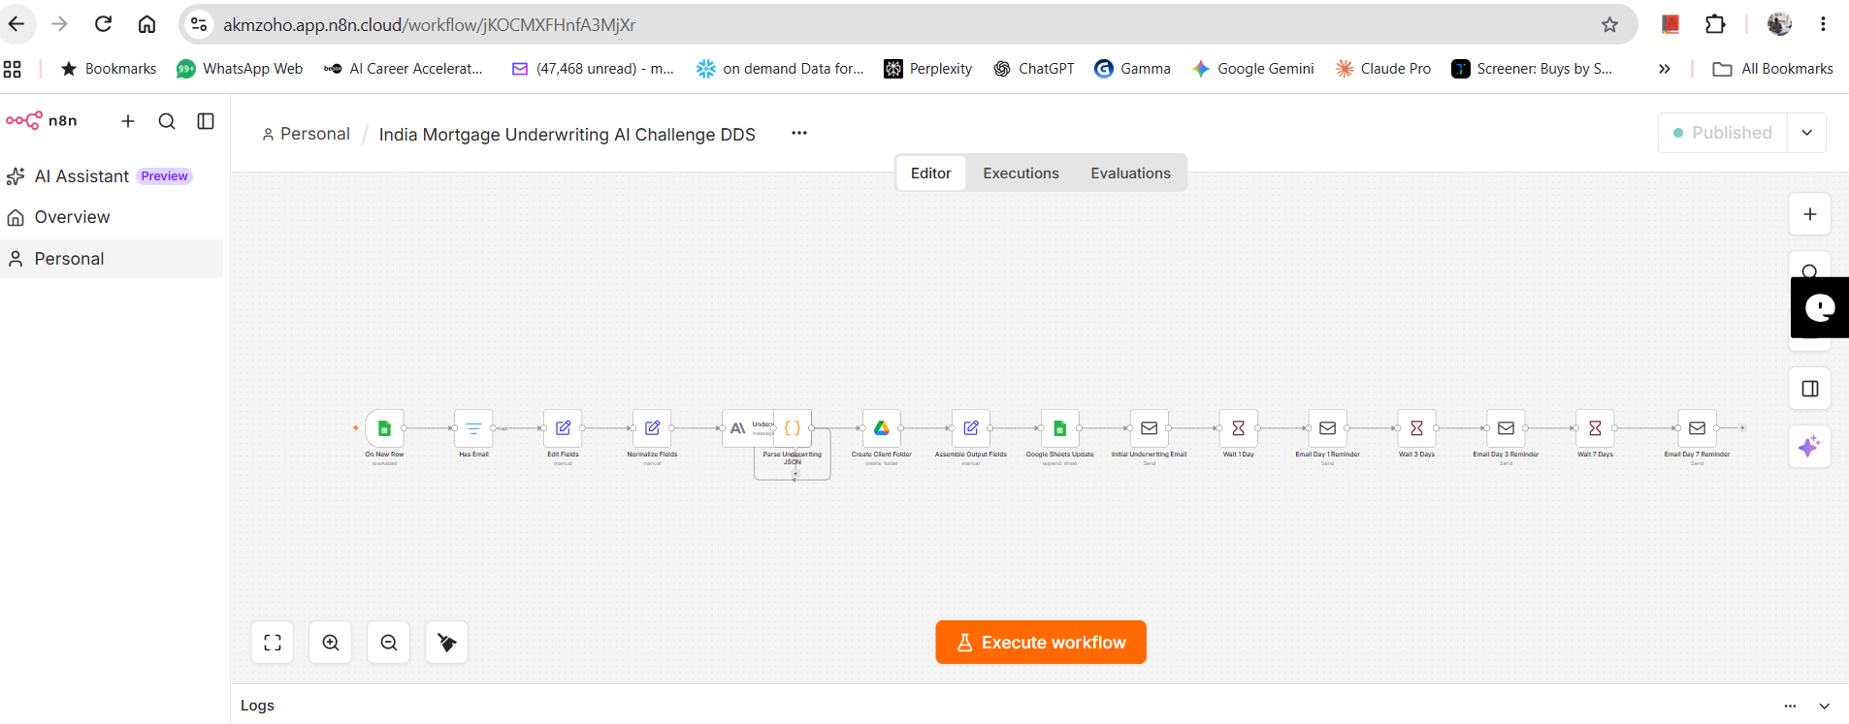

Input sheet : https://docs.google.com/spreadsheets/d/1hrZGFznP1RP-A6tJYGKV-Otyq4EkoSe6Uov1p2T-85g/edit?gid=1712745749#gid=1712745749
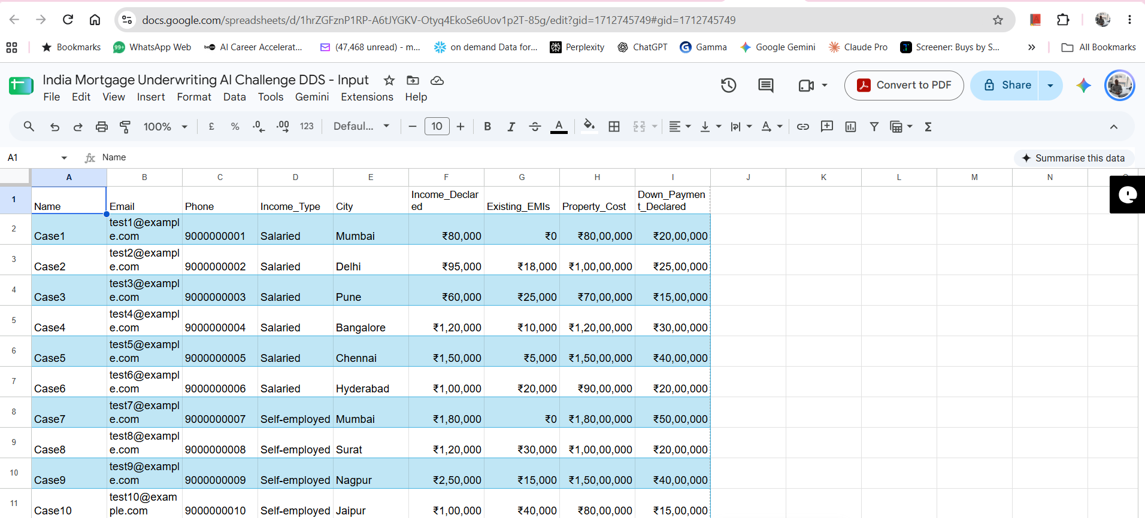

Mortgage output sheet https://docs.google.com/spreadsheets/d/1tdymW6pWYFuCJeaLkC3yxkgtA4cDc8IQXFdyEsA4Bm0/edit?gid=557173883#gid=557173883
